**Installation of VS Code on Windows 11**

**Steps to Download and Install:**

1. **Download VS Code**:
   * Visit the official [Visual Studio Code website](https://code.visualstudio.com/).
   * Click on the "Download for Windows" button to download the installer.

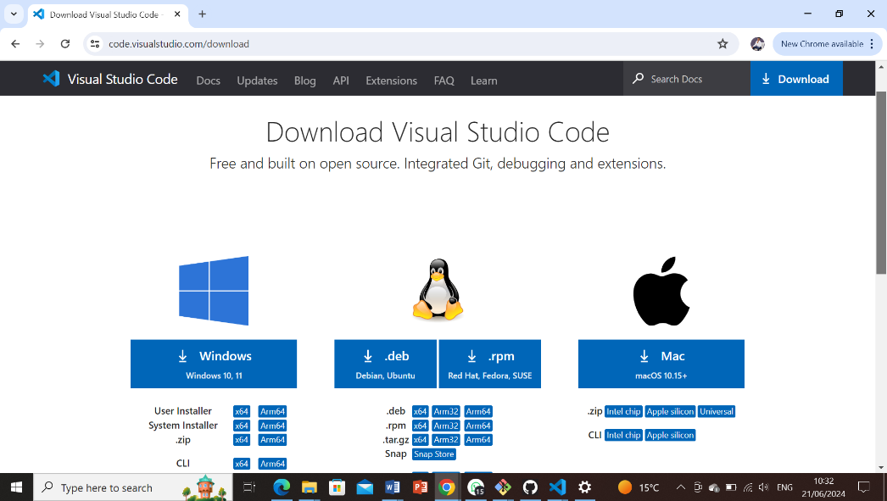

1. **Run the Installer**:
   * Once the download is complete, run the installer file (.exe).
   * Follow the installation wizard prompts. You can choose the default options unless you need to customize the installation path.
2. **Complete Installation**:
   * After installation, VS Code should launch automatically.

**First-time Setup**

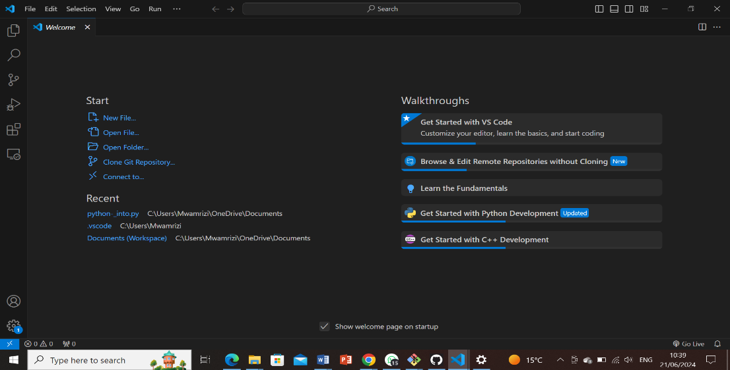

**Initial Configurations and Settings:**

After installing VS Code, adjust the following settings for an optimal coding environment:

* **Extensions**: Install necessary extensions for your workflow.
* **Settings**: Customize editor preferences (e.g., indentation, font size).
* **Keybindings**: Set up keybindings for your preferred shortcuts.
* **Theme**: Choose a theme that suits your preference.

**User Interface Overview**

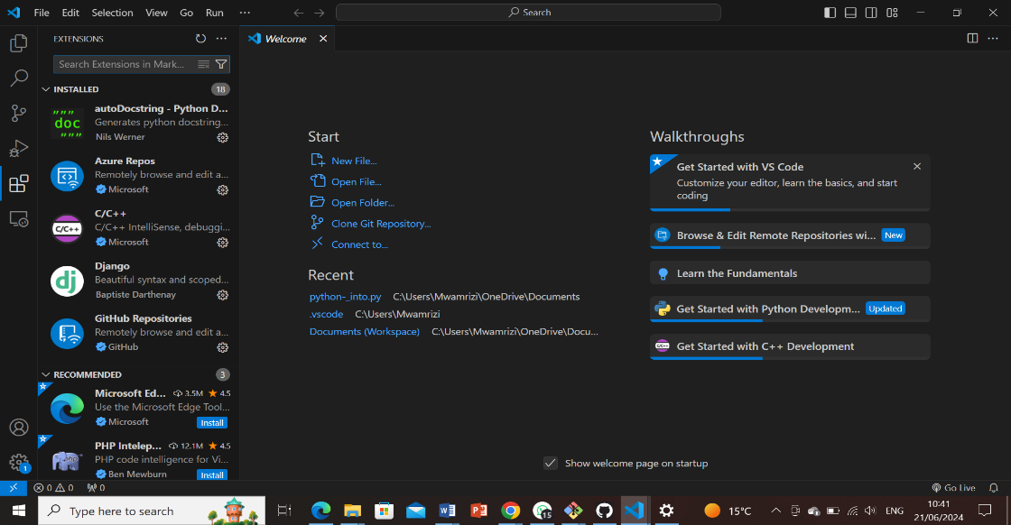

**Components of the VS Code User Interface:**

* **Activity Bar**: Provides quick access to different views like Explorer, Search, Source Control, and Extensions.
* **Side Bar**: Contains views like Explorer (file navigation), Search, Source Control, and Extensions.
* **Editor Group**: Where files are opened for editing.
* **Status Bar**: Displays information about the current state of VS Code and the project (e.g., line endings, Git branch).

**Command Palette**

**Accessing and Using the Command Palette:**

* **Command Palette**: Accessed via Ctrl+Shift+P (Windows). It allows executing various commands and tasks.
* **Examples**: Search for and install extensions, change the editor layout, run tasks, manage Git actions, etc.

**Extensions in VS Code**

**Role of Extensions:**

* **Finding and Installing**: Access the Extensions view (Ctrl+Shift+X), search for extensions, and click install.
* **Managing**: Enable, disable, update, and remove extensions.
* **Examples for Web Development**: Live Server for live reloading, ESLint for JavaScript linting, Prettier for code formatting.

**Integrated Terminal**

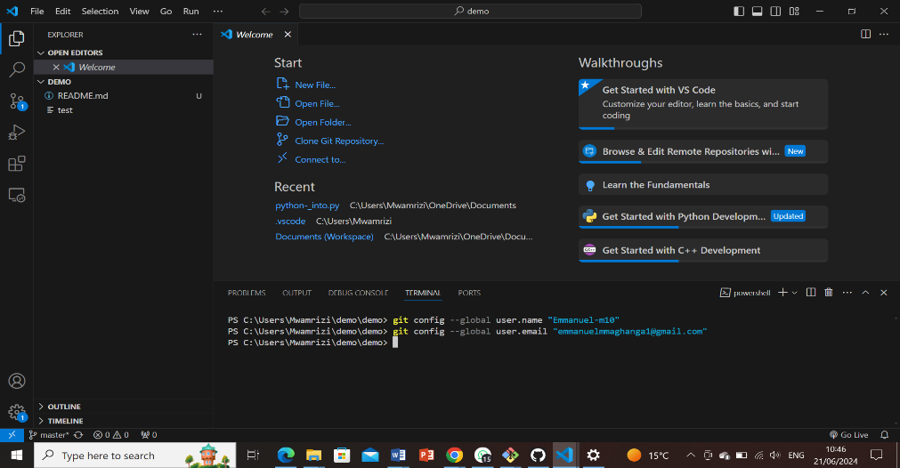

**Opening and Using the Integrated Terminal:**

* Open with Ctrl+`` (backtick) or from the Terminal` menu.
* **Advantages**: Integrated within VS Code, allows seamless interaction with your project’s files and terminals, supports multiple terminals simultaneously.

**File and Folder Management**

**Managing Files and Folders:**

* **Creating**: Use the Explorer view or Ctrl+N to create new files.
* **Opening**: Double-click on files in the Explorer view or use Ctrl+O to open files.
* **Navigation**: Navigate between files using tabs or Ctrl+Tab, navigate between directories using the Explorer view.

**Settings and Preferences**

**Customizing Settings:**

* **Access**: Go to File > Preferences > Settings, or use Ctrl+,.
* **Examples**: Change the theme (workbench.colorTheme), adjust font size (editor.fontSize), modify keybindings (keybindings.json).

**Debugging in VS Code**

**Setting Up and Starting Debugging:**

1. **Configure Debugger**: Create or open a project with source code.
2. **Set Breakpoints**: Click in the gutter next to a line of code.
3. **Start Debugging**: Press F5 or use the Run menu.

**Key Debugging Features:**

* **Watch**: Monitor variables and expressions.
* **Call Stack**: View the stack of function calls.
* **Breakpoints**: Control execution flow.

**Using Source Control (Git)**

**Integrating Git with VS Code:**

1. **Initialize a Repository**:
   * Open a folder, open the Source Control view (Ctrl+Shift+G), and initialize a Git repository.
2. **Making Commits**:
   * Stage changes using + buttons next to changed files in the Source Control view.
   * Enter a commit message and click the check mark to commit.
3. **Pushing Changes to GitHub**:
   * Set up a remote repository on GitHub.
   * Push changes using the Source Control view (... menu > Push).

Ref: *chatGbt and

*

<https://www.geeksforgeeks.org/how-to-install-visual-studio-code-on-windows/>